From main file (WAREHOUSE ORDERS), create a copy of the tab for the intended day to print Shipping Labels and Bill of Lading and move it to another book.

Make sure you’ve extended all cells that were retracted:

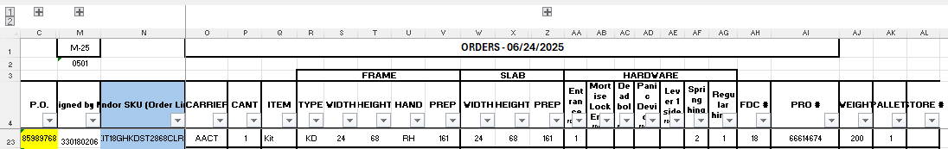



Make sure M2 is updated from Main file (WAREHOUSE ORDERS) to bring the FDC#-day.

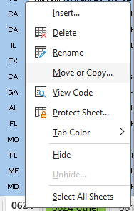 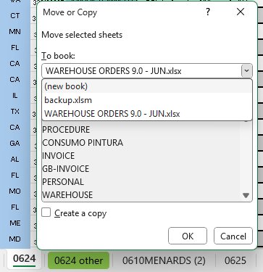



You’ll have a new book with connections to the main file, don’t close main file until you have the new book created as values.



From O5:AL (last FDC) select and unmerge:

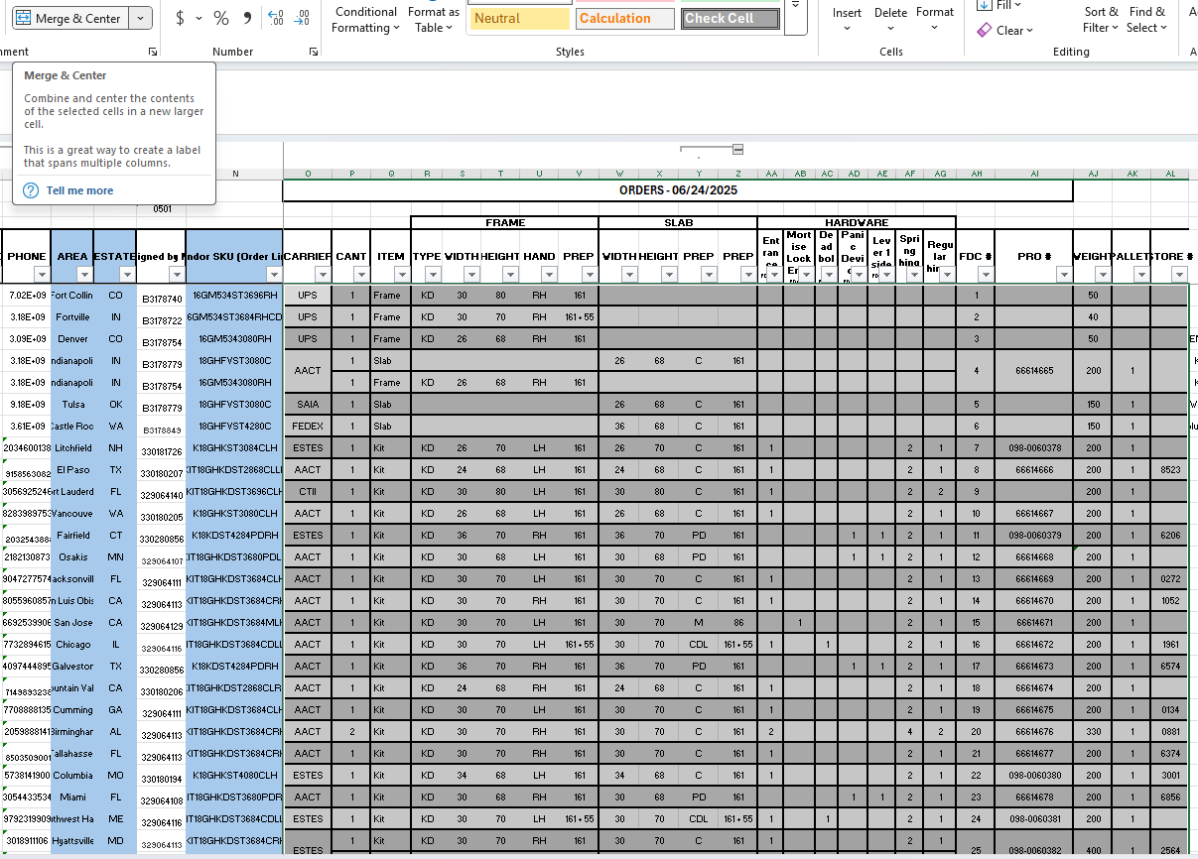



This will allow you to have unmerged rows to copy and paste them as values. You’ll use the tool without any merged values.  
Copy and paste values from A5 all the way down until the last FDC, BR Column. For example, you’ll be copying A5:BR25 as values. Be sure to copy just until BR Column since you’ll have formulas needed in the macro execution from columns BS:BW.

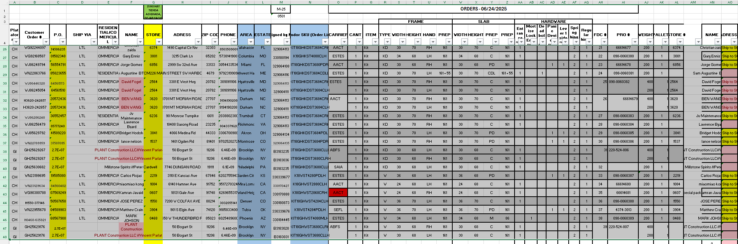

Copy them and paste it as values, it will prevent that any formula from the main file update and change any value.

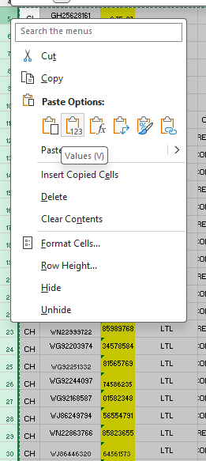



Doing that you’re safe to use the correct values in the tool.

Open the Tool. FileName.xlsm.

Unmerge any the previous production plan from O5:AL, this will allow you to paste values without any issue.

Copy from new book created from WAREHOUSE ORDERS, from row 5 until last FDC and paste them as values. Remember to use the range just until BR.

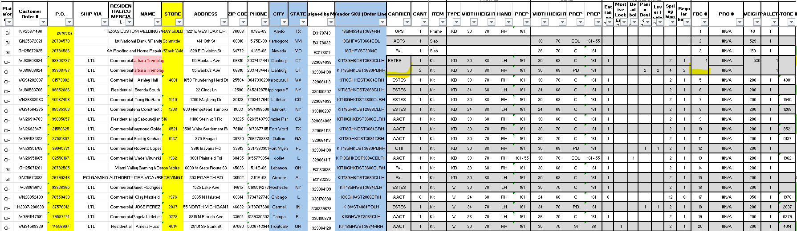

Once you have the values ready to be used in the tool, make sure that you’ll update manually Column BN, it will feed some helpers needed in the macro’s executions. BN will tell the tool to follow the FDC numbers in that range, so it’s very important you adjust any issue you encounter there. Make sure if any FDC is listed in several rows, it should be repeated as the below example for FDC:4  
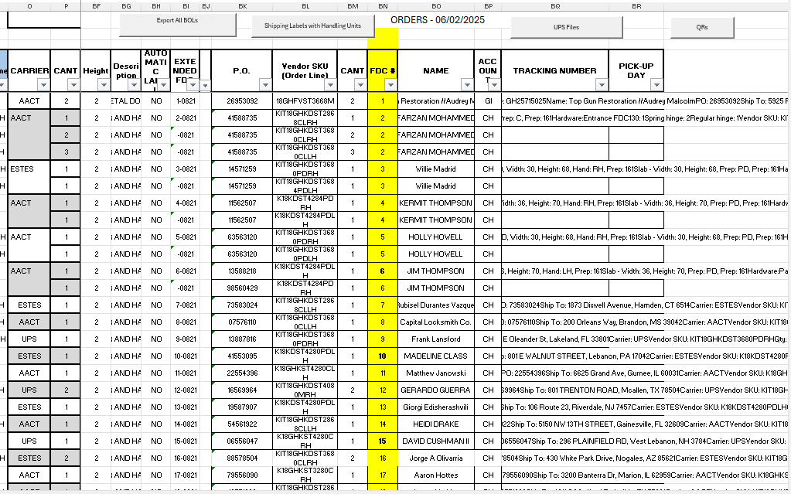

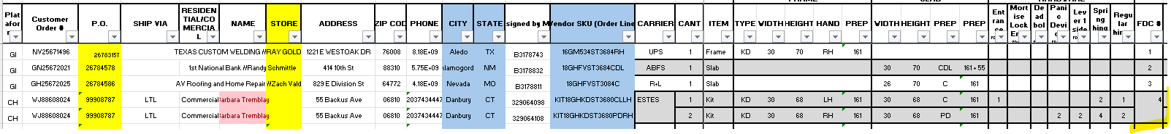

The buttons you’ll use:

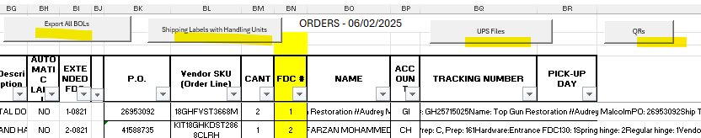

Please note that since shipping labels will retrieve a logo, it will take more time to execute than B.O.L.

There is a new functionality here where Handling Units will provide the labels needed for qty>1. Example below:

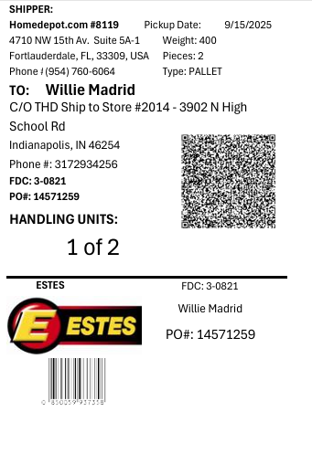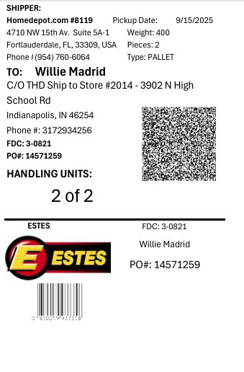

Make sure to wait until each button finish to execute before making any editions or edits in any excel file, it will assure a smooth macro execution.

When clicked it will run to populate a PDF file that will be created in the same folder the tool is located, remember to name it.

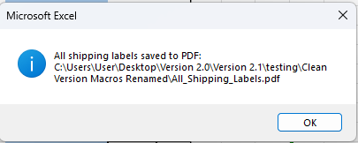

If you didn’t rename the previous files, they will be overwritten due to the same name. I’d recommend to create a separate folder to save labels and B.O.Ls per day for your records.

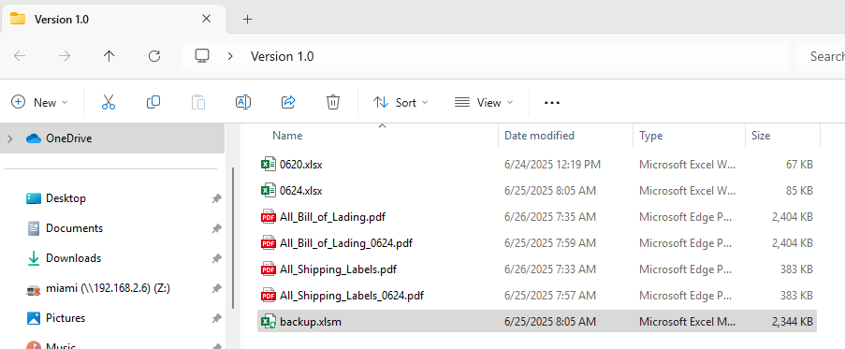

UPS files: this functionality will provide plain files to upload it to UPS and generate the labels.  
  
QRs: This functionality will provide the entire QRs in a single template.

Following those steps, you won’t have any issues using the tool.

Make security copies of the functioning tool for any issue or manipulation that could go wrong.

